**A PRELIMINARY REPORT**

**ON**

**Airlines : We Seek Profit And Trust**

SUBMITTED TO THE SAVITRIBAI PHULE PUNE UNIVERSITY, PUNE

IN THE PARTIAL FULFILLMENT OF THE REQUIREMENTS

FOR THE AWARD OF THE DEGREE

OF

**BACHELOR OF ENGINEERING (ARTIFICIAL INTELLIGENCE AND DATA SCIENCE)**

##### SUBMITTED BY

STUDENT NAME EXAM SEAT NO:

**Shivam Borse** BEAD20119 **Shraddha Lokhande**  BEAD20120 **Urmila Dholi** BEAD20146 **Sarvdnya Dhamale** BEAD20152



## DEPARTMENT OF ARTIFICIAL INTELLIGENCE AND DATA SCIENCE

## DR. D.Y.PATIL INSTITUTE OF ENGINEERING, MANAGEMENT & RESEARCH

AKURDI, PUNE 411044

**SAVITRIBAI PHULE PUNE UNIVERSITY**

**2023 -2024**



**CERTIFICATE**

This is to certify that the project report entitles

**“Airlines : we seek profit and trust”**

Submitted by

STUDENT NAME EXAM SEAT NO

**Shivam Borse** BEAD20119 **Shraddha Lokhande**  BEAD20120 **Urmila Dholi** BEAD20146 **Sarvdnya Dhamale** BEAD20152

is a bonafide student of this institute and the work has been carried out by him/her under the supervision of **Ms. Arti Singh** and it is approved for the partial fulfillment of the requirement of Savitribai Phule Pune University, for the award of the degree of **Bachelor of Engineering** (Artificial Intelligence and Data Science).

**Ms. Arti Singh** **Dr Suvarna Patil**

Guide HOD

Artificial Intelligence & Data Science Artificial Intelligence & Data Science

**Dr. Anupama V. Patil**

**Principal**,

Dr.D.Y.Patil Institute of Engineering,

Management & Research Akurdi Pune – 411044

Place : Pune

Date :

**ACKNOWLEDGEMENT**

It gives us great pleasure in presenting the preliminary project report on ‘Airlines : We Seek Profit And Trust’ .

I would like to take this opportunity to thank my internal guide **Ms. Arti Singh** for giving me all the help and guidance I needed. I am really grateful to them for their kind support. Their valuable suggestions were very helpful.

I am also grateful to **Dr Suvarna Patil**, Head of Computer Engineering Department, Dr. D. Y. Patil Institute of Engineering, Management & Research for his indispensable support, suggestions.

In the end our special thanks to Mrs. Sneha Kanawade for providing various resources such as laboratory with all needed software platforms, continuous guidance, for Our Project.

Name of Student Sign

**Shivam Borse   
Shraddha Lokhande**   **Urmila Dholi   
Sarvdnya Dhamale**

(BE Artificial Intelligence and Data Science)

**ABSTRACT**

In today's competitive aviation industry, airlines face the dual challenge of optimizing profitability while maintaining passenger trust. This project delves into the synergy between these two seemingly disparate goals, exploring the integration of machine learning techniques to achieve both financial success and enhanced customer confidence. Central to the project is the notion of trust, a pivotal factor influencing passengers' decisions in choosing an airline. By employing machine learning to enhance safety measures, personalize passenger experiences, and address customer concerns proactively, airlines can foster trust and loyalty among their clientele.

This project embarks on an exploration of this complex balancing act, offering an in-depth analysis of how machine learning can play a pivotal role in achieving both financial success and enhanced customer trust within the aviation sector.

Trust influences passengers' decisions when choosing airlines for both leisure and business travel. Building and maintaining trust is not only a matter of safety but also a fundamental business imperative.

In conclusion, this project underscores the immense potential of machine learning in helping airlines strike a balance between profitability and passenger trust.

TABLE OF CONTENTS

LIST OF ABBREVATIONS i

LIST OF FIGURES ii

LIST OF TABLES iii

|  |  |  |  |  |
| --- | --- | --- | --- | --- |
| Sr.No. | | Title of Chapter | | Page No. |
| 01 | | **Introduction** | | 10 |
|  | 1.1 | Overview | | 10 |
|  | 1.2 | Motivation | | 10 |
|  | 1.3 | Problem Definition and Objectives | | 11 |
|  | 1.4 | Project Scope & Limitations | | 11 |
|  | 1.5 | Methodologies of Problem solving | |  |
| 02 | | Literature Survey | | 12 |
| 03 | | Software Requirements Specification | | 14 |
|  | 3.1 | Assumptions and Dependencies | | 14 |
|  | 3.2 | Functional Requirements | | 16 |
|  |  | 3.2.1 | System Feature 1(Functional Requirement) |  |
|  |  | 3.2.2 | System Feature2 (Functional Requirement) |  |
|  |  |  | …… |  |
|  |  |  | …… |  |
|  | 3.3 | External Interface Requirements (If Any) | | 16 |
|  |  | 3.3.1 | User Interfaces | 16 |
|  |  | 3.3.2 | Hardware Interfaces | 16 |
|  |  | 3.3.3 | Software Interfaces | 17 |
|  |  | 3.3.4 | Communication Interfaces | 17 |
|  | 3.4 | Nonfunctional Requirements | | 17 |
|  |  | 3.4.1 | Performance Requirements |  |
|  |  | 3.4.2 | Safety Requirements |  |
|  |  | 3.4.3 | Security Requirements |  |
|  |  | 3.4.4 | Software Quality Attributes |  |
|  | 3.5 | **System Requirements** | | 18 |
|  |  | 3.3.1 | Database Requirements |  |
|  |  | 3.3.2 | Software Requirements(Platform Choice) |  |
|  |  | 5.3.3 | Hardware Requirements |  |
|  | 3.6 | Analysis Models: SDLC Model to be applied | | 20 |
|  | 3.7 | System Implementation Plan | | 20 |
| 04 | | System Design | | 22 |
|  | 4.1 | System Architecture | |  |
|  | 4.2 | Data Flow Diagrams | |  |
|  | 4.3 | Entity Relationship Diagrams | |  |
|  | 4.4 | UML Diagrams | |  |
| 05 | | Other Specification | | 28 |
|  | 5.1 | Advantages | |  |
|  | 5.2 | Limitations | |  |
|  | 5.3 | Applications | |  |
| 06 | | **Conclusions & Future Work** 29 | | |  |
|  | | **Appendix A:**  Problem statement feasibility assessment using, satisfiability analysis and NP Hard,NP-Complete or P type using modern algebra and relevant mathematical models.  **Appendix B:**  Details of the papers/Copyright. Summary of the Paper/copyright in not more than 3-4 lines. Here you should write the seed idea of the papers/ copyright you had referred for preparation of this project report in the following format.  Example:  Thomas Noltey, Hans Hanssony, Lucia Lo Belloz,”Communication Buses for Automotive Applications” In *Proceedings of the* 3rd *Information Survivability Workshop (ISW-2007)*, Boston, Massachusetts, USA, October 2007. IEEE Computer Society.  **Appendix C:** Plagiarism Report | | |  | |
|  | | References | | 29 |

**LIST OF ABBREVATIONS**

|  |  |
| --- | --- |
| **Abbreviation** | **Illustration** |
| HTTP | Hyper Text Transfer Protocol |
| MQTT | Message Query Telemetry Transport |
|  |  |
|  |  |
|  |  |
|  |  |

**LIST OF FIGURES**

|  |  |  |
| --- | --- | --- |
| **Figure** | **Illustration** | **Page No.** |
| 1 | Waterfall Model | 20 |
| 2  3 | Timeline Chart  System Architecture | 20  22 |
| 4 | DFD Level – 0 | 23 |
| 5 | DFD Level – 1 | 23 |
| 6  7 | DFD Level – 2  ER Diagram | 24  25 |
| 8 | Use Case Diagram | 26 |
| 9 | Sequence Diagram | 26 |
| 10 | Activity Diagram | 27 |

**LIST OF TABLES**

|  |  |  |
| --- | --- | --- |
| **Table** | **Illustration** | **Page No.** |
| 4.1 | Project Plan | 22 |

1. **INTRODUCTION**
   1. **OVERVIEW**

In today's competitive aviation industry, airlines face the dual challenge of optimizing profitability while maintaining passenger trust. This project delves into the synergy between these two seemingly disparate goals, exploring the integration of machine learning techniques to achieve both financial success and enhanced customer confidence. Central to the project is the notion of trust, a pivotal factor influencing passengers' decisions in choosing an airline. By employing machine learning to enhance safety measures, personalize passenger experiences, and address customer concerns proactively, airlines can foster trust and loyalty among their clientele.

* 1. **MOTIVATION**

The aviation industry is a dynamic and ever-evolving sector that plays a pivotal role in global connectivity and economic growth. As millions of people take to the skies each day, the safety, reliability, and quality of their travel experiences remain paramount. Airlines are not just in the business of transporting passengers from one destination to another; they are in the business of trust. This trust, fostered by airlines, is the very foundation of their success, as it directly impacts passengers' choices, loyalty, and ultimately, the airline's profitability. In today's real-time, hyper-connected world, the motivation for this project lies at the intersection of two key factors: the relentless pursuit of financial success and the imperative need to cultivate and maintain passenger trust.

Machine learning stands as the bridge between the inherent challenges of optimizing profitability and maintaining passenger trust in real time. The ability to analyze vast datasets, predict safety issues, personalize passenger experiences, and monitor online sentiment is a game-changer for airlines in the digital age. By harnessing the power of these algorithms, airlines can meet the ever-evolving needs and expectations of passengers while ensuring safety is not compromised.

Project is driven by the urgency and necessity of addressing these real-time challenges that airlines face in the modern world. The motivation lies in the critical intersection of economic viability, passenger expectations, and the transformative potential of machine learning to help airlines achieve both profitability and passenger trust. The aviation industry's future success hinges on its ability to adapt to the real-time demands of its passengers, and this project aims to shed light on the path forward in navigating this complex terrain.

* 1. **PROBLEM STATEMENT AND OBJECTIVE**

**Problem Statement:**

With the help of machine learning algorithms, the aviation industry can embark on a transformative journey towards achieving financial success and bolstering customer confidence within a real-time framework. This endeavor involves meeting the evolving needs and expectations of passengers while maintaining an unwavering commitment to safety and reliability. To address this intricate challenge, this project aims to explore and propose solutions that harness the potential of machine learning, fundamentally reshaping the aviation industry's strategy for optimizing profitability and building and preserving passenger trust.

**Objectives:**

* Leverage Real-Time Data for Decision-Making
* Optimize Operational Efficiency Instantaneously
* Dynamic Fleet Management
* Upsell and Cross-Sell Strategies
* Ancillary Revenue Generation
* Maximize Revenue Generation
* Agile Market Response
* Continuous Cost Reduction through Data-driven Decision
  1. **PROJECT SCOPE**

**Project Scope:**

This project focuses on leveraging real-time machine learning and data-driven strategies to maximize profitability within the aviation industry while maintaining safety, reliability, and customer confidence. The scope encompasses a comprehensive approach to address the multifaceted challenges and opportunities in a real-time environment.

1. **LITERATURE SURVEY**

|  |  |  |  |  |
| --- | --- | --- | --- | --- |
| **Sr.**  **No** | **Paper Title** | **Journal Name** | **Authors &**  **Publication Date** | **Methodology** |
| 1 | A Framework for Airfare Price Prediction: A Machine Learning Approach |  | Neha Agarwal  IEEE Trans. Intelligence July 2021 | To build the airline ticket price model at the market segment level, information about both the airline traffic and passenger volume for each market segment is  required.  Data collected during  2018 are used to train and evaluate the proposed model. Table I summarizes the information of these two datasets. |
| 2 | New reference trajectory optimization algorithm for a flight management system inspired in beam search |  | Received 19 August 2016; revised 22 September 2016; accepted 28 October 2016 Available online 21 June 2017 | 1. Numerical performance model 2. Flight cost computation 3. Space search: Decision graph 4. Problem definition 5. Calculate the optimal aircraft trajectory, was conceived by taking into account ATM constraints such as constant Mach and constant altitude segments following a pre-defined lateral reference route |
| 3 | A Time-Optimal Trajectory Algorithm Based on Accessibility Analysis |  | Mehmet Ali Onde  2021 5th International Conference on Robotics and Automation Sciences | * Industrial robots Deceleration point determination Safety optimization * Validate the effectiveness of the developed algorithm. * Apply the algorithm to various path types (straight line, arc, spline curve) to demonstrate its practical utility. * As a performance analysis Root Mean Squared Error (RMSE) calculated by the mathematical formula as shown in Equation – |
| 4 | Airline ticket price and demand prediction:  A survey |  | Article history: Received  3 September 2018 Revised  5 January 2019Accepted  1 February 2019 Available online 5 February 2019 | 1. The main goal is increasing revenue and maximizing profit.    2.Present -comprehensive literature review of existing studies related to this topic which can be utilized by future researchers |

1. **SOFTWARE REQUIREMENT SPECIFICATION**
   1. **INTRODUCTION**

**3.1.1 PROJECT SCOPE**

competitive aviation industry airlines face real time flight scheduling problem due to which dual challenge of optimizing profitability while maintaining passenger trust occur

* + 1. **USE CLASSES AND CHARACTERISTICS**

Our system is divided into two class/modules

1. Customer
2. Aviation Industry Owner‘s
3. Flight Scheduler
4. Crew Members And Staff
   * 1. **ASSUMPTIONS AND DEPENDENCIES**

* Availability of Real-Time Data
* Stakeholder Commitment
* Data Accuracy
* Technology Integration
* Market Dynamics
* Operational Teams
  + 1. **MATHEMATICAL MODELING**

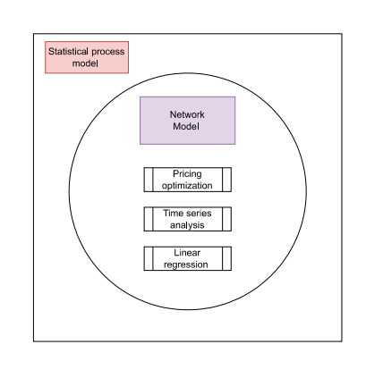

**Figure 3.1.4 : Mathematical Structure**

A statistical process model is a framework used in various fields, including statistics, engineering, and quality management, to describe and analyze the behavior of a process or system over time. It involves the use of statistical techniques and methods to model, understand, and control processes to ensure they meet specific objectives, such as producing products within specified tolerances or achieving desired outcomes.

A network model refers to a conceptual or mathematical representation of a system that consists of interconnected components or nodes. Network models are used in various fields to study and understand the relationships, interactions, and flows within complex systems. There are different types of network models, each tailored to a specific application or problem domain.

Price optimization is a strategy and process used by businesses to set and adjust the prices of their products or services in a way that maximizes profitability or achieves specific business objectives. It involves using data, analytics, and various pricing strategies to find the optimal balance between maximizing revenue, sales volume, and customer satisfaction. Price optimization is crucial in industries such as retail, e-commerce, hospitality, and many others where pricing decisions directly impact a company's bottom line.

Dynamic Pricing: Dynamic pricing involves adjusting prices in real-time based on various factors, including demand, time of day, competitor prices, and inventory levels. Airlines and online retailers frequently use dynamic pricing.

Time series analysis is a statistical technique used to analyze and interpret data that is collected or recorded over a series of equally spaced time intervals. Time series data often exhibit trends, seasonality, and patterns, and time series analysis helps uncover and understand these underlying structures.

Components of Time Series:

* Trend: The long-term movement or direction in the data. Trends can be increasing, decreasing, or stable.
* Seasonality: Regular patterns or fluctuations that occur at consistent intervals, such as daily, monthly, or yearly cycles.
* Cyclical Patterns: Longer-term fluctuations that are not strictly periodic and can be influenced by economic or other factors.
* Irregular or Residual Component: The random or unpredictable fluctuations that remain after removing trend, seasonality, and cyclical patterns.

**Set Theory**

Simple Linear Regression: Y = α + βX + ε

Multiple Linear Regression: Y = α + β₁X₁ + β₂X₂ + ... + βₖXₖ + ε

Y represents the dependent variable , X₁, X₂, ..., Xₖ represent the independent variables.

α is the y-intercept (the value of Y when all independent variables are zero).

β₁, β₂, ..., βₖ are the coefficients that represent the impact of each independent variable on Y.

ε is the error term, representing the random variation that cannot be explained by the model.

**Space Complexity:**

The space complexity depends on space complexity(during run time)= O(m).

**Time Complexity:**

Train -time complexity = O((m^2)*(n+m)) run -time complexity= O(m)

* 1. **FUNCTIONAL REQUIRMENTS**
* System must be capable of integrating real-time data from various sources, including flight operations, passenger booking systems, market data, and customer feedback.
* Real-time reporting and monitoring dashboards should be provided to allow stakeholders to track key performance indicators, model accuracy, and profitability metrics.
* Continuous monitoring of market dynamics and competitor actions in real time is necessary for agile pricing and marketing strategies.
* Ancillary revenue streams will be optimized, enhancing profitability through personalized upselling and cross-selling strategies, including premium seats, in-flight services, and partner promotions.
  1. **EXTERNAL INTERFACE REQUIREMENTS**

1. **USER INTERFACES**

The requirements section of hardware includes minimum of 180 GB hard disk and 4 GB RAM with 2 GHz or higher speed. The primary requirements include a memory of 4GB for the Android Application development and MySQL , Jupiter Notebook for python file (.ipynb formate )

1. **HARDWARE INTERFACES**

As this is an online application for product management we are not enabling or installing any hardware components for user interface.

It’s not an embedded system

* + - Processor – Intel i5
    - Speed - 4.5 Ghz and Above
    - RAM - 4 GB (min)
    - Hard Disk – 1TB
    - Key Board - Standard Windows Keyboard
    - Mouse

1. **SOFTWARE INTERFACES**

This is the software configuration in which the project was shaped. The programming language used, tools used, etc are described here.

* Operating System : Windows 11
* Front End :  HTML , CSS , JS
* Tool :  Jupiter Notebook
* Database : MySQL , Python

1. **COMMUNICATION INTERFACES**

* User can access the web application from remote location.
* Standard internet connection is required.
* TCP/UDP connection will be required.
* In backend we use Flask framework to communicate with model .h5 file and the front end html page to get input from the user
  1. **NON-FUNCTIONAL REQUIREMENTS**

1. **PERFORMANCE REQUIREMENTS**

1) Real-Time Responsiveness

2) User Interface Responsiveness

3) System Monitoring and Alerting

1. **SAFETY REQUIREMENTS**

Encompass various aspects, including data security to safeguard passenger information, real-time monitoring to detect and respond to safety-critical issues, and compliance with aviation safety guidelines and best practices. Additionally, the project must ensure that any real-time decisions, whether related to pricing, resource allocation, or operations, prioritize safety above all other considerations. Safety drills and simulations should be conducted to prepare for emergency scenarios and to validate the project's safety procedures.

1. **SECURITY REQUIREMENTS**

Data Encryption: All sensitive data, especially passenger information and financial transactions, must be encrypted during transmission and storage to prevent unauthorized access.

Access Control: Robust access control mechanisms should be in place, allowing only authorized personnel to access and modify system components and data.

Authentication and Authorization: User authentication and authorization protocols must be implemented to ensure that only authorized individuals can perform specific actions within the system.

Vulnerability Assessment: Regular vulnerability assessments and penetration testing should be conducted to identify and remediate security weaknesses in the system.

1. **SOFTWARE QUALITY ASSURANCE**

* Quality Standards: Adherence to recognized software quality standards, such as ISO 9001 or ISO 25000, to maintain a structured approach to quality assurance
* Testing Framework: Establishment of a comprehensive testing framework, covering unit testing, integration testing, system testing, and user acceptance testing to validate the system's functionality, performance, and security.
* Quality Metrics: Defining and monitoring quality metrics and key performance indicators (KPIs) to assess and improve the project's quality over time.
* Code Reviews: Regular code reviews to identify and address coding issues, ensure code readability, and maintain coding standards.
* Continuous Integration and Deployment (CI/CD): Implementation of CI/CD pipelines to automate testing, build, and deployment processes, enhancing system reliability and consistency.
  1. **SYSTEM REQUIREMENTS**

1. **DATABASE REQUIREMENTS**

i) Flight Information:

Flight Schedule: Information about scheduled flights, including flight numbers, departure and arrival airports, departure and arrival times, aircraft type, and flight duration.

Aircraft Information: Details about the aircraft available for scheduling, such as aircraft ID, capacity, and maintenance status.

ii) Crew Information:

Crew Schedules: Crew scheduling data, including schedules for pilots, flight attendants, and other crew members.

Crew Qualifications: Information about crew qualifications, certifications, and training records.

iii) Airport Information:

Airport Data: Information about airports, including their codes, locations, runways, and facilities.

Airport Restrictions: Data on any operational restrictions or limitations at each airport, such as curfews, noise restrictions, and customs/immigration procedures.

iv) Route Data:

Flight Routes: Data on potential flight routes, waypoints, and airways.

Air Traffic Control Information: Information about air traffic control procedures and airspace restrictions.

v) Passenger Data:

Passenger Reservations: Data related to passenger reservations, bookings, and ticketing, which may include passenger names, contact details, and seat assignments.

vi) Maintenance Records:

Aircraft Maintenance Records: Historical data on aircraft maintenance and inspection schedules.

vii) Regulatory Compliance:

Regulatory Data: Information on aviation regulations and compliance requirements that impact scheduling

viii) Weather Data:

Real-time Weather Information: Integration with external weather data sources for current weather conditions, forecasts, and severe weather alerts.

1. **SOFTWARE REQUIREMENTS**

Operating system : Windows 11

Coding Language : Python

IDE : Jupiter Notebook

1. **HARDWARE REQUIREMENTS**

System :         Intel I5 Processor and above.

Hard Disk           : 1TB.

Monitor : 15 VGA Color.

Ram : 16 GB.

* 1. **ANALYSIS MODELS : SDLC MODEL TO BE APPLIED**

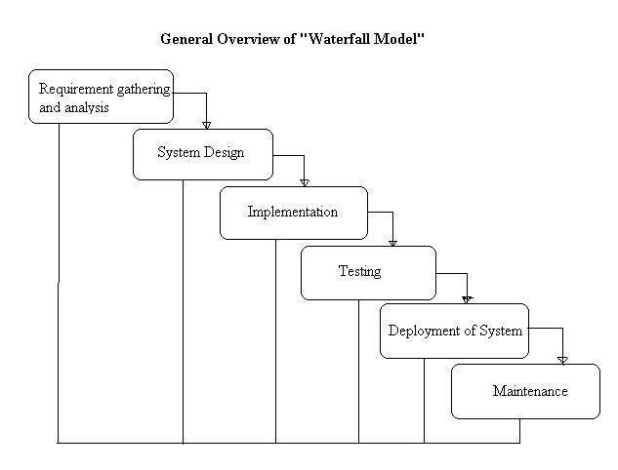

**Figure3.6: Software Development Model**

* 1. **SYSTEM IMPLEMENTION PLAN**

**1. Requirement gathering and analysis:**

In this step of waterfall we identify what are various requirements are need for our project such are software and hardware required, database, and interfaces.

**2. System Design:**

In this system design phase we design the system which is easily understood for end user i.e. user friendly.

We design some UML diagrams and data flow diagram to understand the system flow and system module and sequence of execution.

**3. Implementation:**

In implementation phase of our project we have implemented various module required of successfully getting expected outcome at the different module levels.

With inputs from system design, the system is first developed in small programs called units, which are integrated in the next phase. Each unit is developed and tested for its functionality which is referred to as Unit Testing.

**4. Testing:**

The different test cases are performed to test whether the project module are giving expected outcome in assumed time.

All the units developed in the implementation phase are integrated into a system after testing of each unit. Post integration the entire system is tested for any faults and failures.

**5. Deployment of System:**

Once the functional and nonfunctional testing is done, the product is deployed in the customer environment or released into the market.

**6. Maintenance:**

There are some issues which come up in the client environment. To fix those issues patches are released. Also to enhance the product some better versions are released. Maintenance is done to deliver these changes in the customer environment.

All these phases are cascaded to each other in which progress is seen as flowing steadily downwards like a waterfall through the phases. The next phase is started only after the defined set of goals are achieved for previous phase and it is signed off, so the name "Waterfall Model". In this model phases do not overlap.

1. **SYSTEM DESIGN**
   1. **SYSTEM ARCHITECTURE**

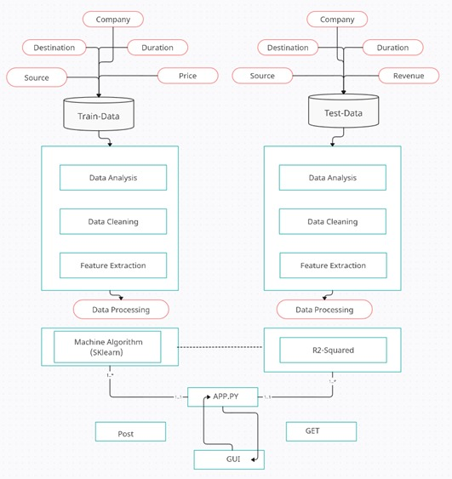

**Figure 4.1 : System Architecture Figure**

* 1. **DATA FLOW DIAGRAMS**

**DFD level 0**

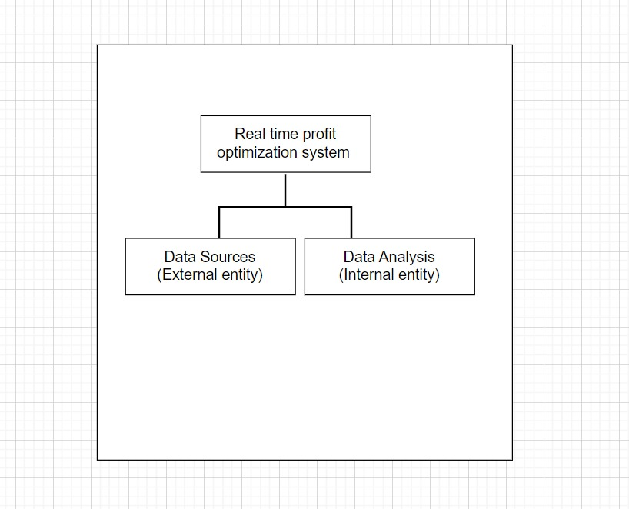

**Figure 4.2.a : Initial Flow of DFD**

**DFD level 1**

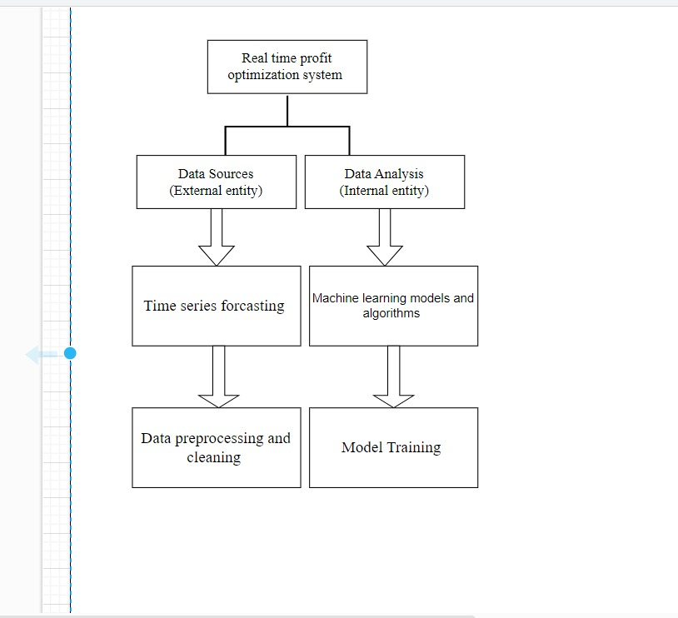

**Figure 4.2.b : Intermediate Flow of DFD**

**DFD level 2**

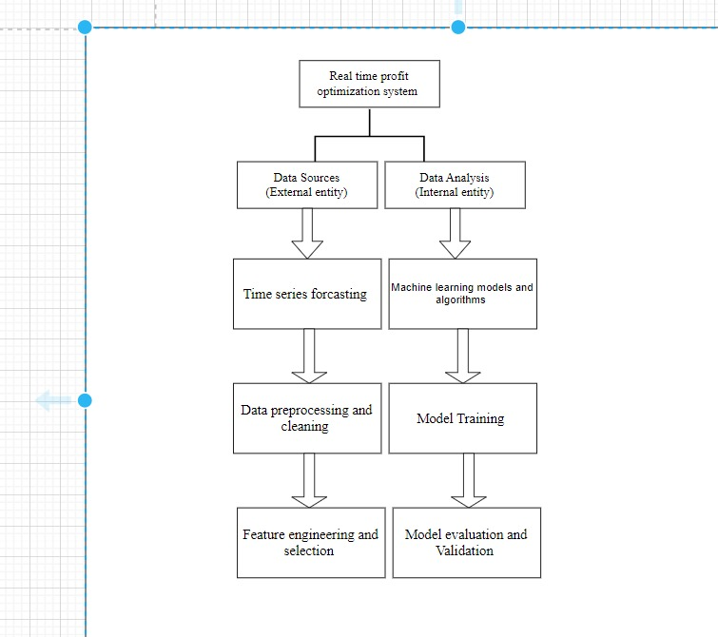

**Figure 4.2.c : Final Structure Of DFD**

* 1. **ENTITY RELATIONSHIP DIAGRAMS**

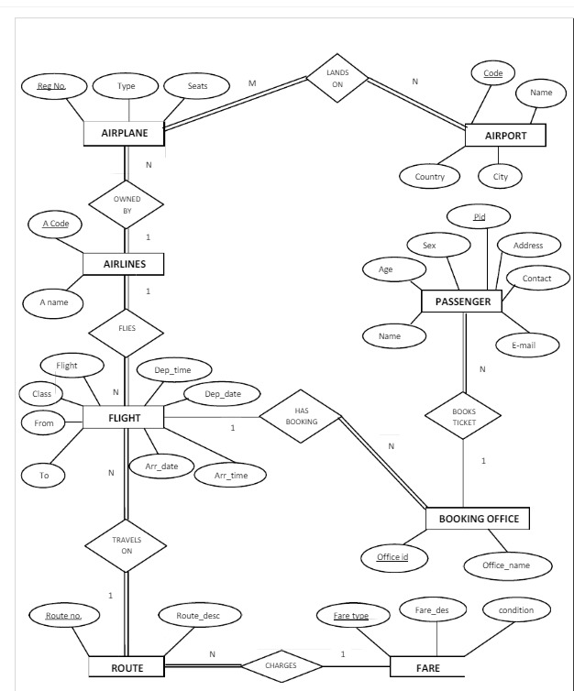

**Figure 4.3 : ER Diagram**

* 1. **UML DIAGRAM**

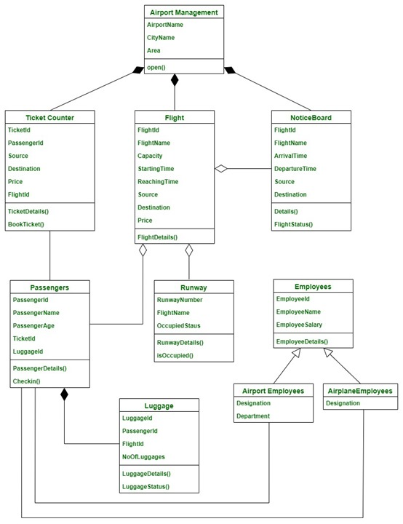

**Figure 4.4.a : Sequence Diagram**

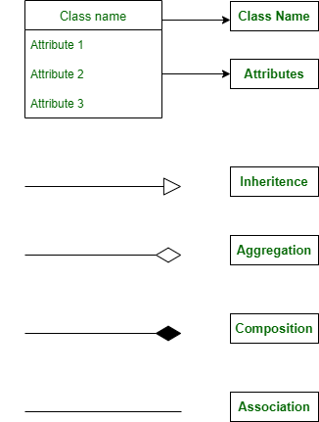

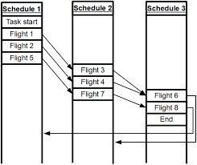

**Figure 4.4.b: Activity Diagram**

1. **OTHER SPECIFICATION**

**5.1 ADVANTAGES**

* Safety and Reliability:
* Improved Cost Management
* Revenue Maximization:
* Optimized Resource Utilization Minimized Delays

**5.2 LIMITATIONS**

* Hardware Embedding
* Network Topology

1. **CONCLUSION & FUTURE WORK**

**Conclusion**:

It affect severely the profitability of airlines and it may widens the trust deficit between cutomer and business partner .Unnecessary expenditure on fuel which is more or less common in aviation industry shall be continue .In today's aviation industry flight scheduling is becoming a challenging task for schedulers. Thus we here developed a machine learning model to enhance the accuracy in flight scheduling with robustness. Model takes real time customer data and according to the demand it schedules the flight. This helps to save money and provide trustworthy service to customers.

**Future scope:**

* This research tries to analyze the time series data of the Airline Industry and build a statistical model that could efﬁciently predict the Upcoming Schedule of Flight .
* This is mainly due to the reason that based on the forecasts the emergency flight schedule are developed. Short-term forecasting problems include predicting future events only up to a small time period.
* Develop algorithm trains a machine learning model works on real time airline industry data.

**References:**

1. Member,Croft,E.A."Trajectory-Planning-for-Robots:the-Challenges-of-Industrial Consider."
2. KAMAL KENT, ZUCKER SW. Toward efficient trajectory planning: the path-velocity decomposition. The International journal of robotics research. 1986; 5(3):72-89. Accessed April 8, 2021.
3. Gill M. Aviation: benefits beyond borders. Geneva, Switzerland: Air Transport Action Group (ATAG); 2014.
4. International Civil Aviation Organization. Aviation’s contribution to climate change, ICAO environmental report. Montreal, Canada: International Civil Aviation Organization (ICAO); 2010.
5. J. Stavins, “Price discrimination in the airline market: The effect of market concentration,” Review of Economics and Statistics, vol. 83, no. 1, pp. 200–202, 2001.
6. B. Mantin and B. Koo, “Dynamic price dispersion in airline markets,” Transportation Research Part E: Logistics and transportation Review, vol. 45, no. 6, pp. 1020–1029, 2009 .